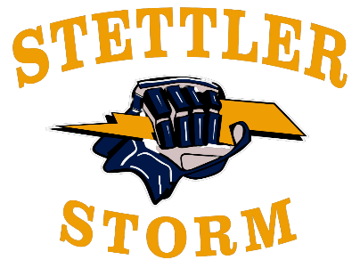

**SMHA Mouthguard Policy**

**Introduction:**

This policy outlines the mandatory requirement of wearing mouthguards for participants in minor hockey leagues. The purpose is to prioritize player safety and reduce the risk of concussion injuries during gameplay.

**Scope:**

This policy is mandatory for all U13-U18 players registered with the Stettler Minor Hockey Association. It is strongly recommended that all U11 players and U11-U18 goalies wear a mouthguard.

**Policy Statement:**

Mandatory Use: All U13-U18 players (excluding goalies) participating in minor hockey leagues are required to wear mouthguards during all practices and games.

Type of Mouth Guard:

An Intra-oral Mouthguard will:

* Be of any colour
* Be of one-piece (1) construction
* Be easily sized by the participant or the participant´s parents
* Be of an even thickness from the front to the back of the device
* Engage the teeth of the upper jaw and the lower jaw
* Maintain alignment of the upper and lower jaw in a neutral position
* Be able to be attached externally to the face mask or shield, or be form fitted or custom fitted to the teeth
* In the case of non-contact play will provide not less than one (1) millimeter of shock absorbent thickness between the teeth of the upper and lower jaw of a player, and
* In the case of contact play will provide not less than two (2) millimeters of shock absorbent thickness between the teeth of the upper and lower jaw of a player.

Enforcement:   
Players, parents and coaches are responsible for ensuring compliance with this policy. Players found not wearing mouth guards will not be permitted to participate until they are properly equipped.

Exemption:  
Players may be exempt from wearing a mouthguard with a signed doctor’s note.

**Rationale:**

Injury Prevention: Concussion injuries are common in hockey due to high-speed collisions, falls, and contact with equipment or other players. Mouth guards act as a protective barrier, reducing the risk of concussions by up 64% (Chrisholm, 2020).

This policy aims to ensure a safe and enjoyable hockey experience for all participants while emphasizing the importance of injury prevention and player welfare.